ST IGNATIUS PARISH
INTERNATIONAL EVENING – CAROL SINGING

Come join us for an evening of fun, food and carol singing from around the world!

There will be a raffle and games and entertainment for all.
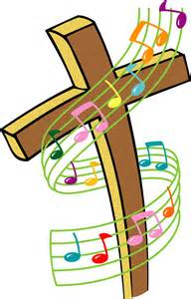
Please bring a national dish from your country.
Raffle £1 per ticket strip – there are 3 prizes
Games
Name the country
Guess the drink

WHEN: SATURDAY 7TH JANUARY 2017

WHERE: PRESBYTERY

TIME: 5:00pm-8:00pm

IF YOU WOULD LIKE TO GET INVOLVED ON THE NIGHT AND SING A CHRISTMAS CAROL IN YOUR LANGUAGE OR TELL A STORY FROM YOUR COUNTRY.
PLEASE CONTACT DEE- 07799 584846 or AMPARO - 07883 448820 RAFAL – 07825 409171

